|  |  |  |
| --- | --- | --- |
| **LAB 321 Assignment** | **Type:** | **Long Assignment** |
| **Code:** | **J3.L.P0012** |
| **LOC:** | **700** |
| **Slot(s):** | **15** |

**Title:** Handyman service

**Background**

### A handyman, also known as a handyperson or handworker is a person skilled at a wide range of repairs, typically around the home. These tasks include trade skills, repair work, [maintenance](https://en.wikipedia.org/wiki/Maintenance,_repair_and_operations) work, are both interior and exterior, and are sometimes described as "side work," "odd jobs" or "fix-up tasks". Specifically, these jobs could be light [plumbing](https://en.wikipedia.org/wiki/Plumbing) jobs such as fixing a leaky toilet or light [electric](https://en.wikipedia.org/wiki/Electrician) jobs such as changing a light fixture.

### Market estimate

An estimate was that in 2003, the market for home-maintenance and repair spending was up 14% from 2001 to 2003. Another estimate was that the market in the United States was $126 billion and was increasing by about 4% annually. American homes are aging; one estimate was that in 2007, more than half of all homes are older than 25 years. And, as populations worldwide tend to become older, on average, and since increasingly elderly people will be less inclined and able to maintain their homes, it is likely that demand for handyman services will grow.

If you want to startup with your handy man service, try this assignment ☺

Reference site: <http://us-123handyman.simplesite.com/>

**Program Specifications**

Program a web site to provide handyman service to your customer, detail functions of this website is described below

**Features:**

This website contains 4 main functions

* Function 1 : Home page : ( see PIC 01 + PIC 02)
  + Display introduction entry and top 3 service sort by published date
  + Each service contains
    - Entry name
    - Description picture
    - Entry content
    - Published date
* Function 2 : Price list ( PIC 05)
  + Print out detail price of our services
* Function 3 :References ( see PIC 04)
  + Show all message from user, allow any user to feedback about our serices
* Function 4 : Contact us ( PIC 03)
  + Allow user contact via contact form .

You do not need to write interface for admin control panel, you can add data manually (use SQL SERVER Management studio).

Note: All data must be load from database, not hard code in page.

***Expectation of User interface:***

Pic 01 : Home Page ( TOP)

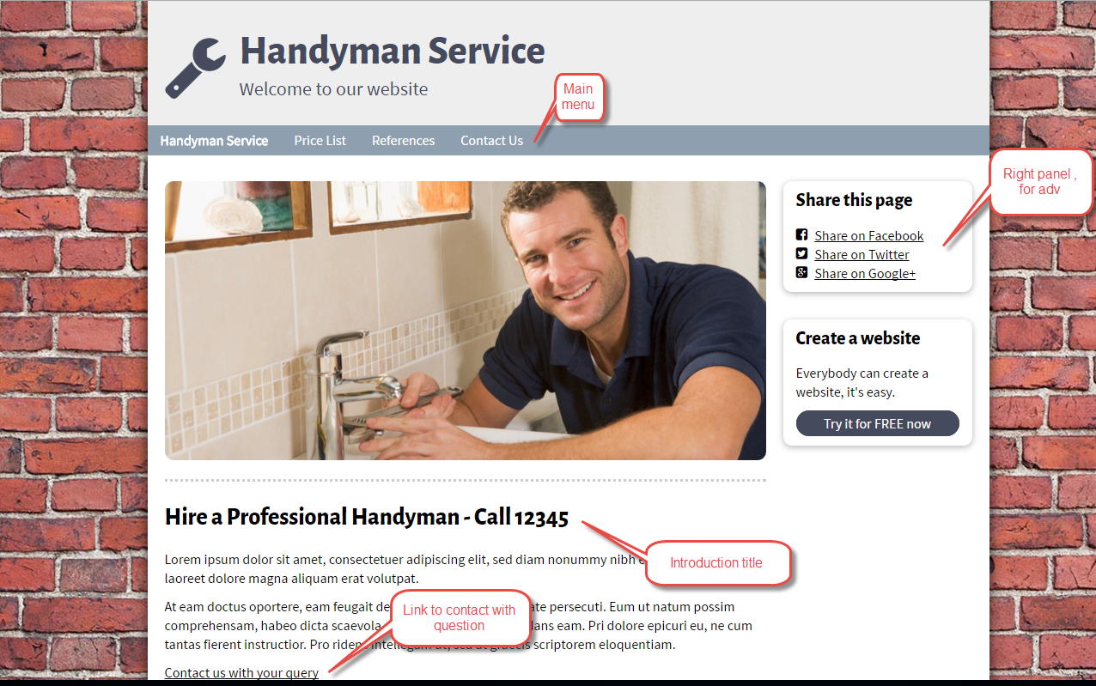

PIC 2 : HOME PAGE ( Bottom )

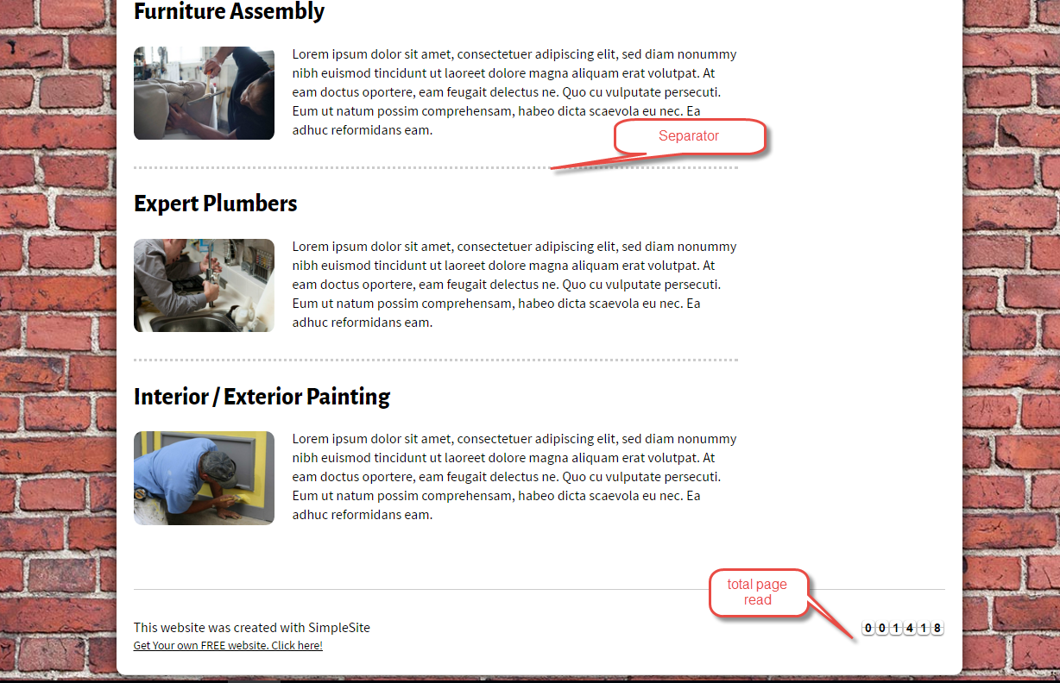

Pic 03 : Contact us page

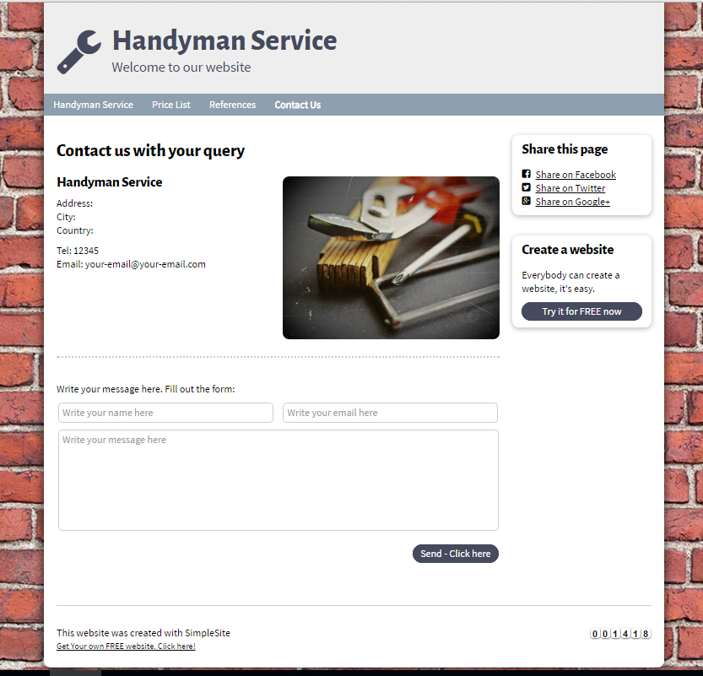

PIC 04 : Reference Page

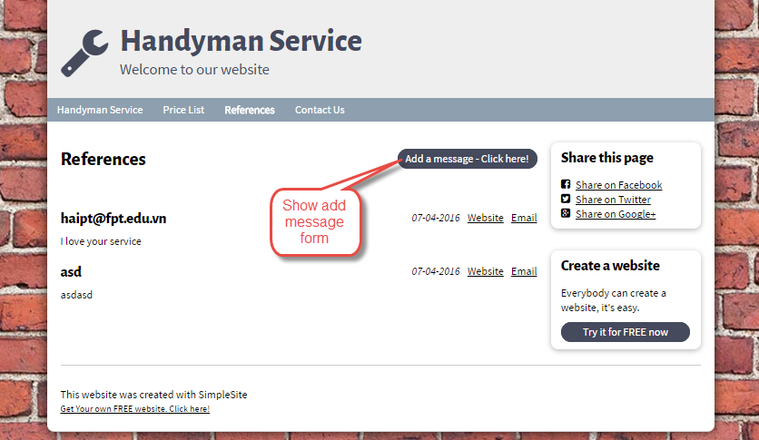

Add message Form

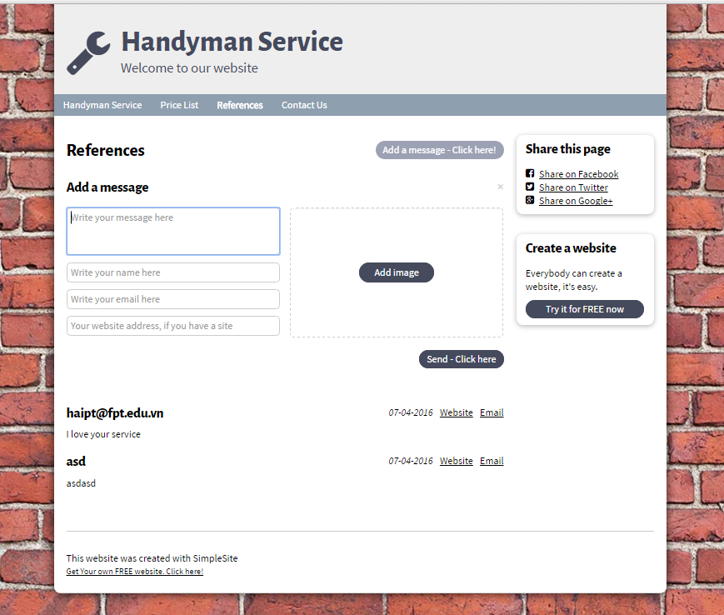

PIC 05

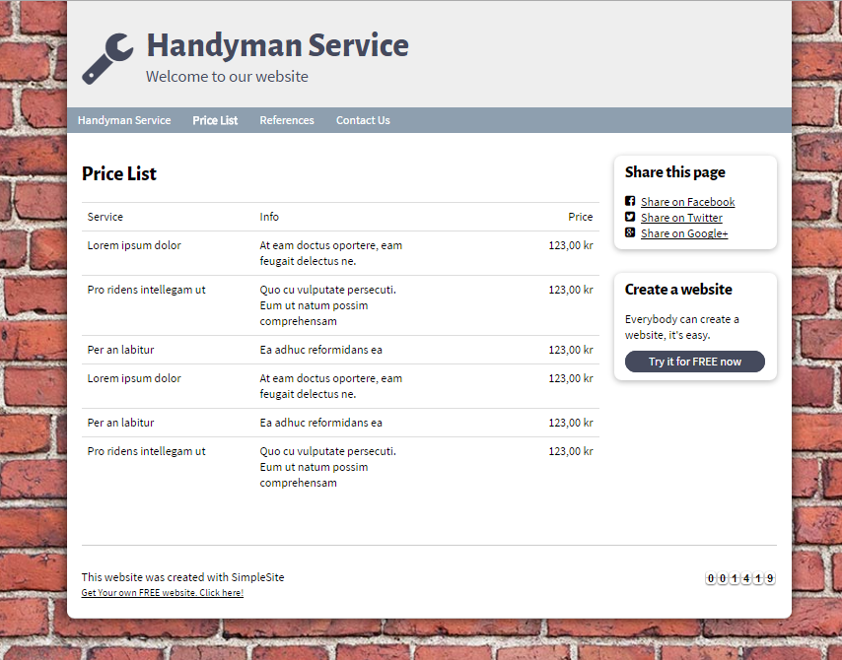

**Guidelines**

* Step 1 : Create web layout
* Step 2 : Create prototype
* Step 3 : Design database base on created prototype
* Step 4 : Code & Test